**Proven partner when handling sensitive, petrochemical products**

**IRAN Oil Show: Present with LocTeq at the Iran Oil Show**

Together with its partner LocTeq, the Möllers Group presented itself to trade visitors at the Iran Oil Show, the international fair for oil, gas and petrochemicals, in Teheran. While LocTeq advises companies in the petrochemical industry on optimizing business processes, the Möllers Group, as an experienced partner to the petrochemical industry, provides complete lines for filling, palletizing, wrapping and loading of plastic granules.

For decades, the Beckum manufacturer has been handling highly sensitive products in the petrochemical industry. The solutions from the Möllers Group along the Full Line are also optimally tailored to specific tasks such as the risk of contamination and special safety requirements.

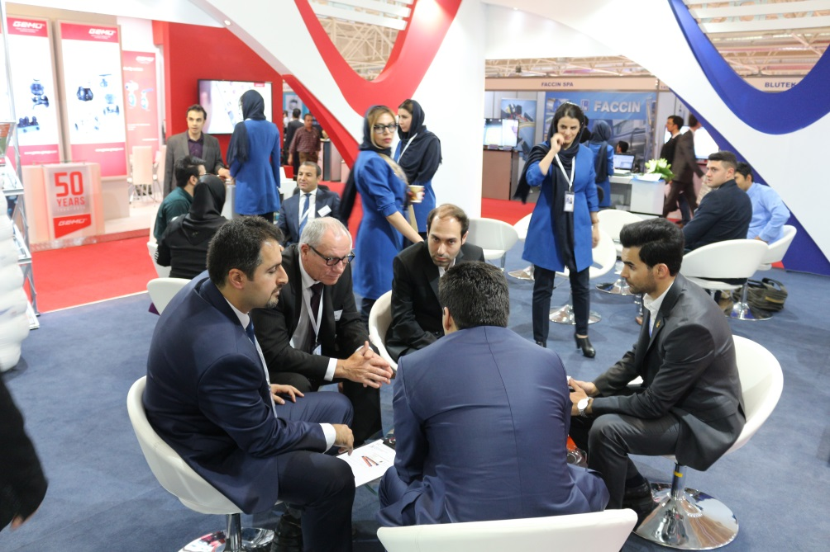

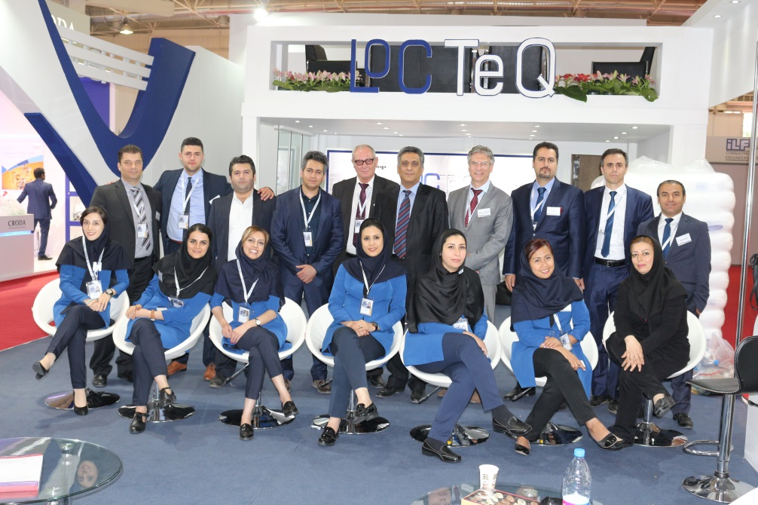

The Iran Oil Show offered the best opportunity to expand existing contacts, meet customers and partners and initiate new projects.